Steps involved in BI Report Creation

● Create New data model

● Querying corresponding report

● If needed create parameters and List of Values/Bursting

● Then view the data model in Table view

● Save the sample data and then save.

● Then export

● XML file will be downloaded and save this xml file into chainsys folder

● Open that file in word remote desktop

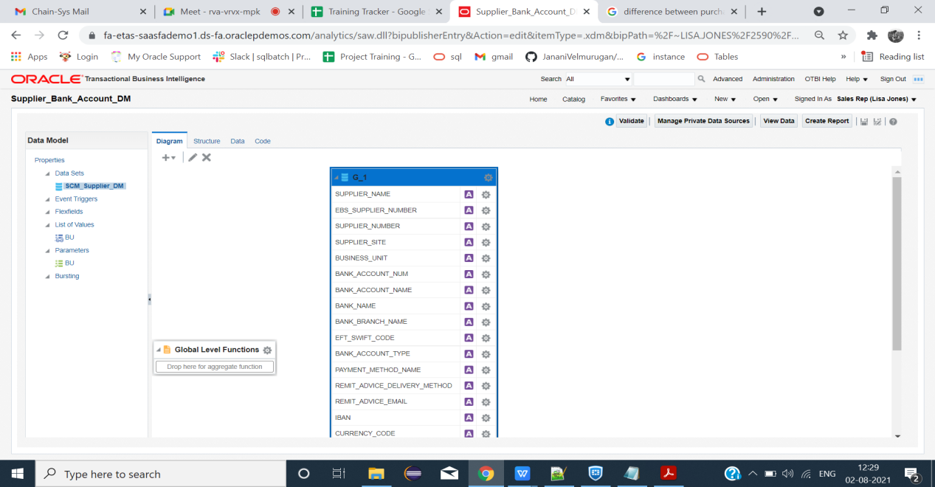

**LIST OF VALUES(LOV):**

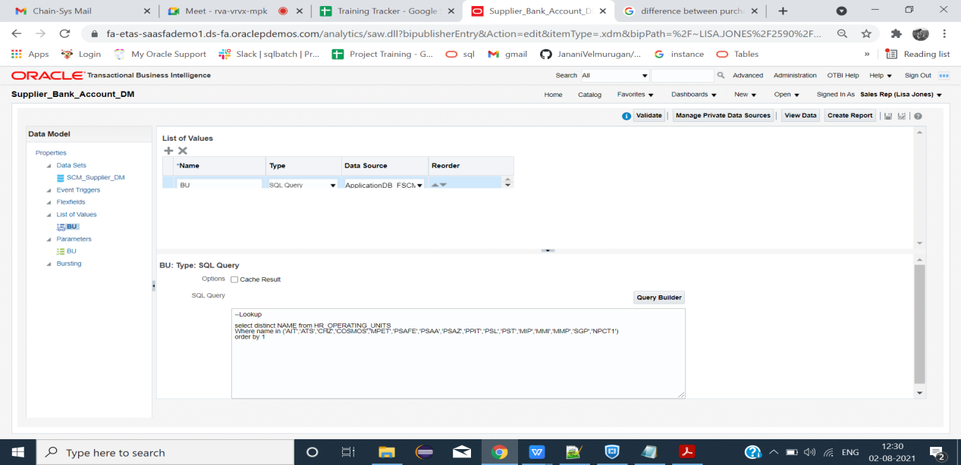

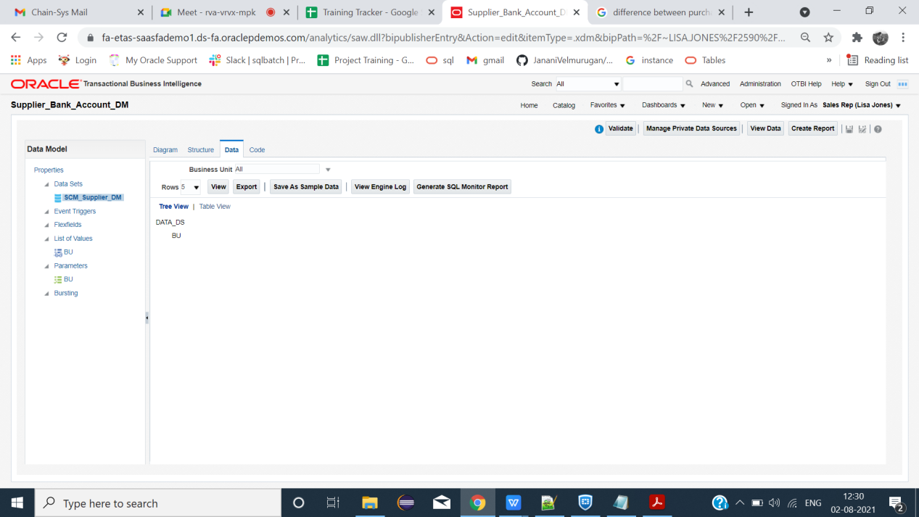

Steps Involved in Excel Template

* Open new excel sheet
* Load the sample data
* Then click fields, after clicking Metadata(XDO_METADATA) will be created.
* Unhide the METADATA by right clicking sheet1
* Create needed column names and insert the fields to its corresponding
* columns.
* Select the inserted fields and give repeating group.
* Then save in (excel 97-2003 workbook) format and click excel.

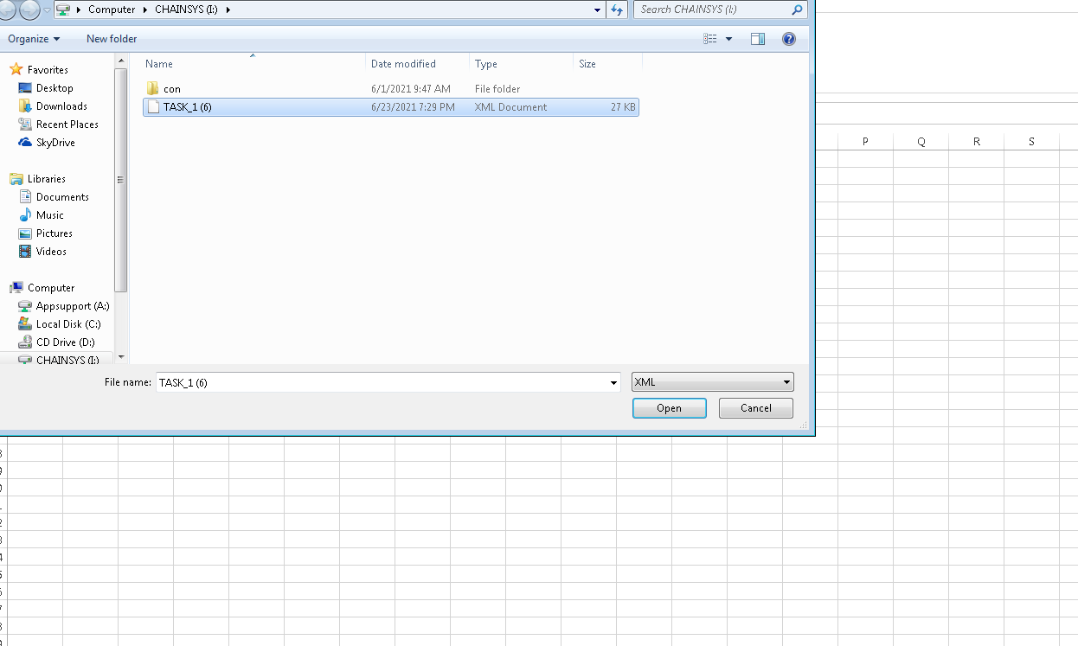

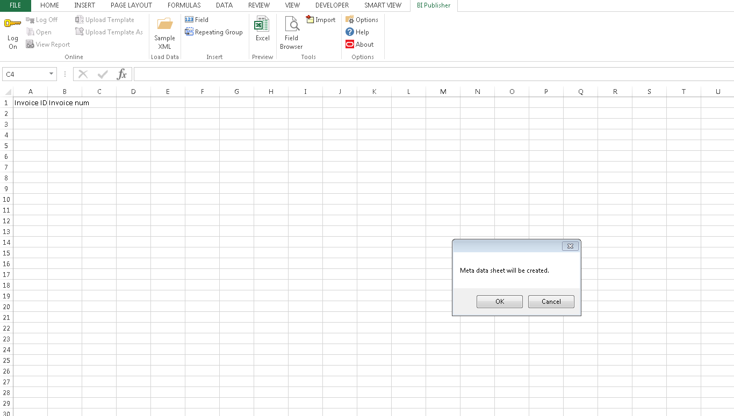

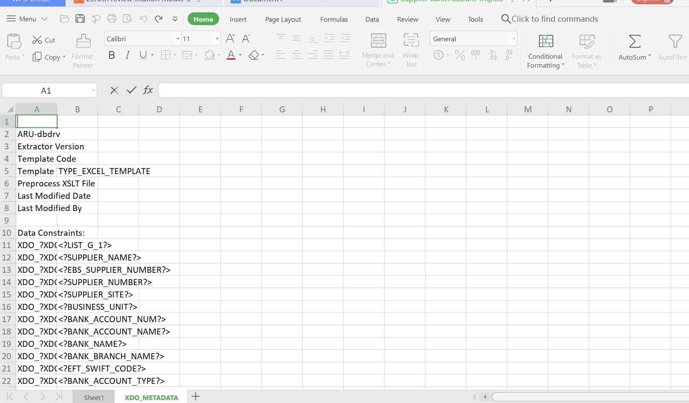

**Template:**

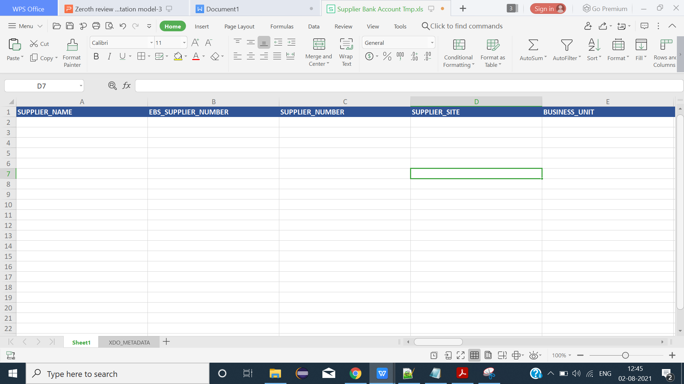

**Report Creation:**

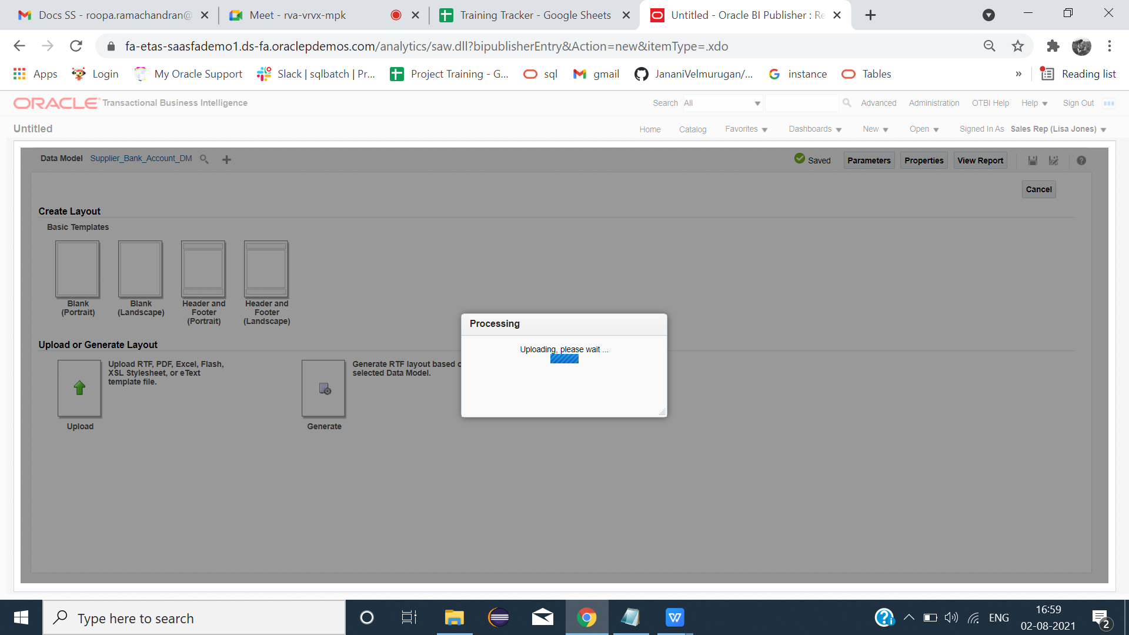

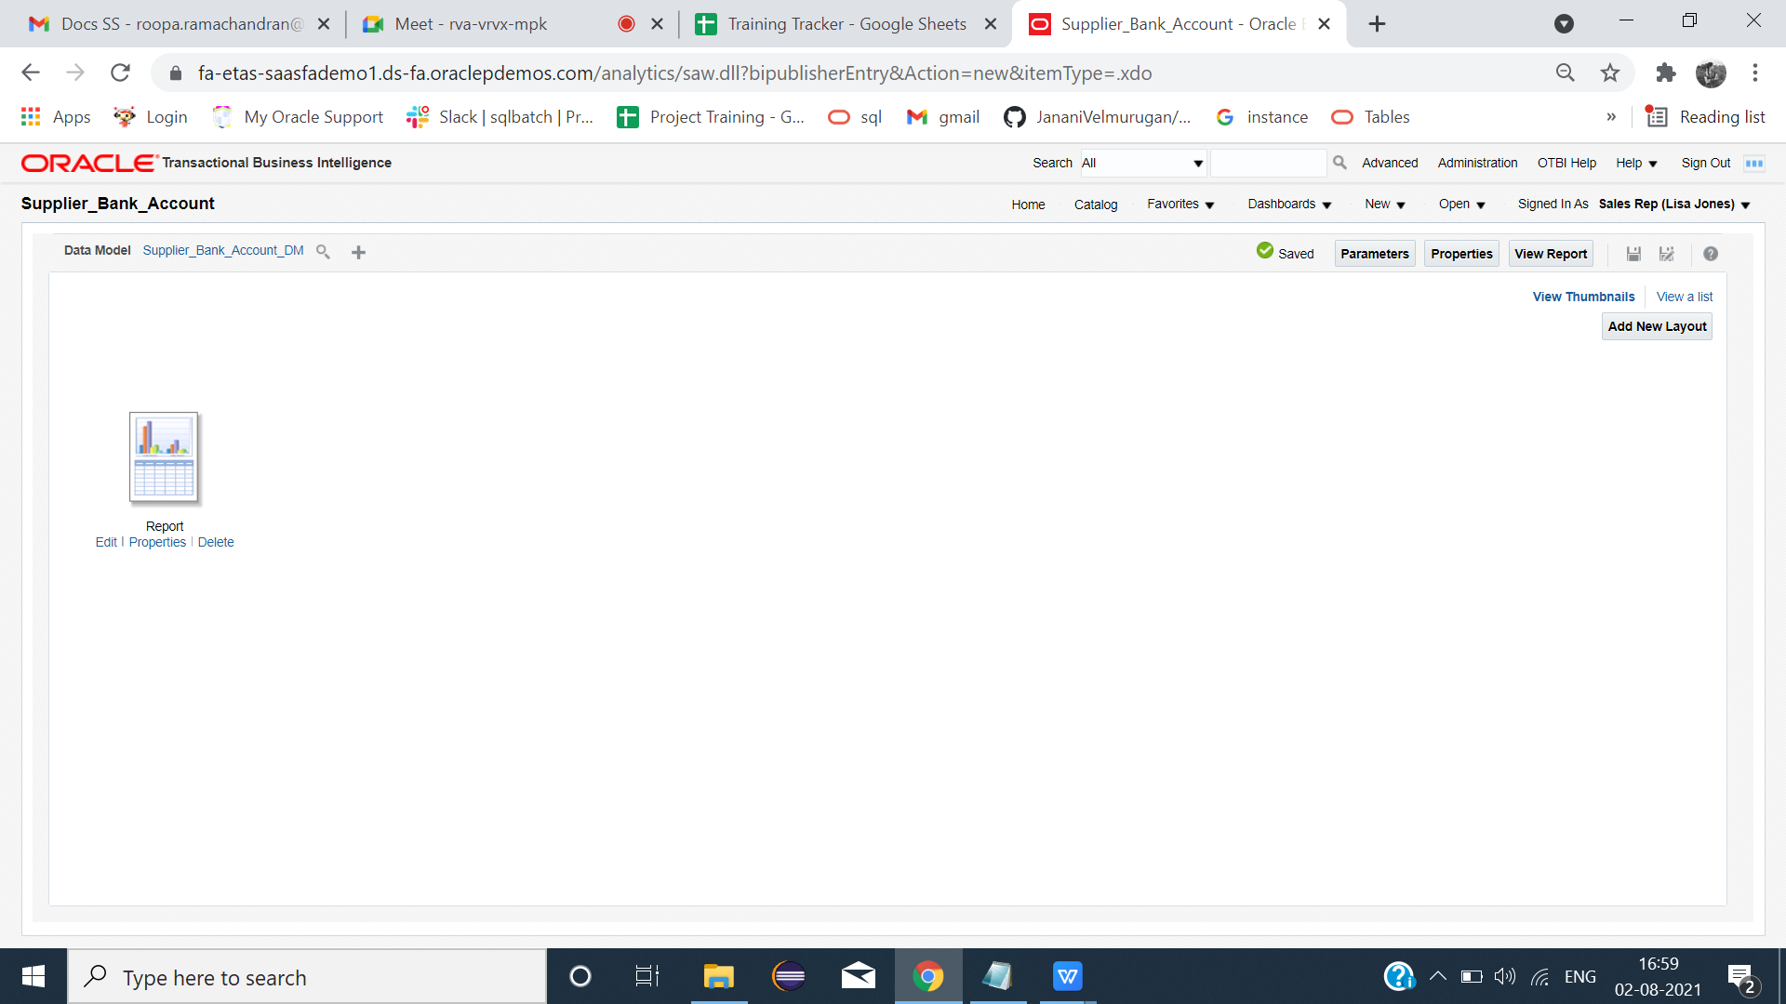

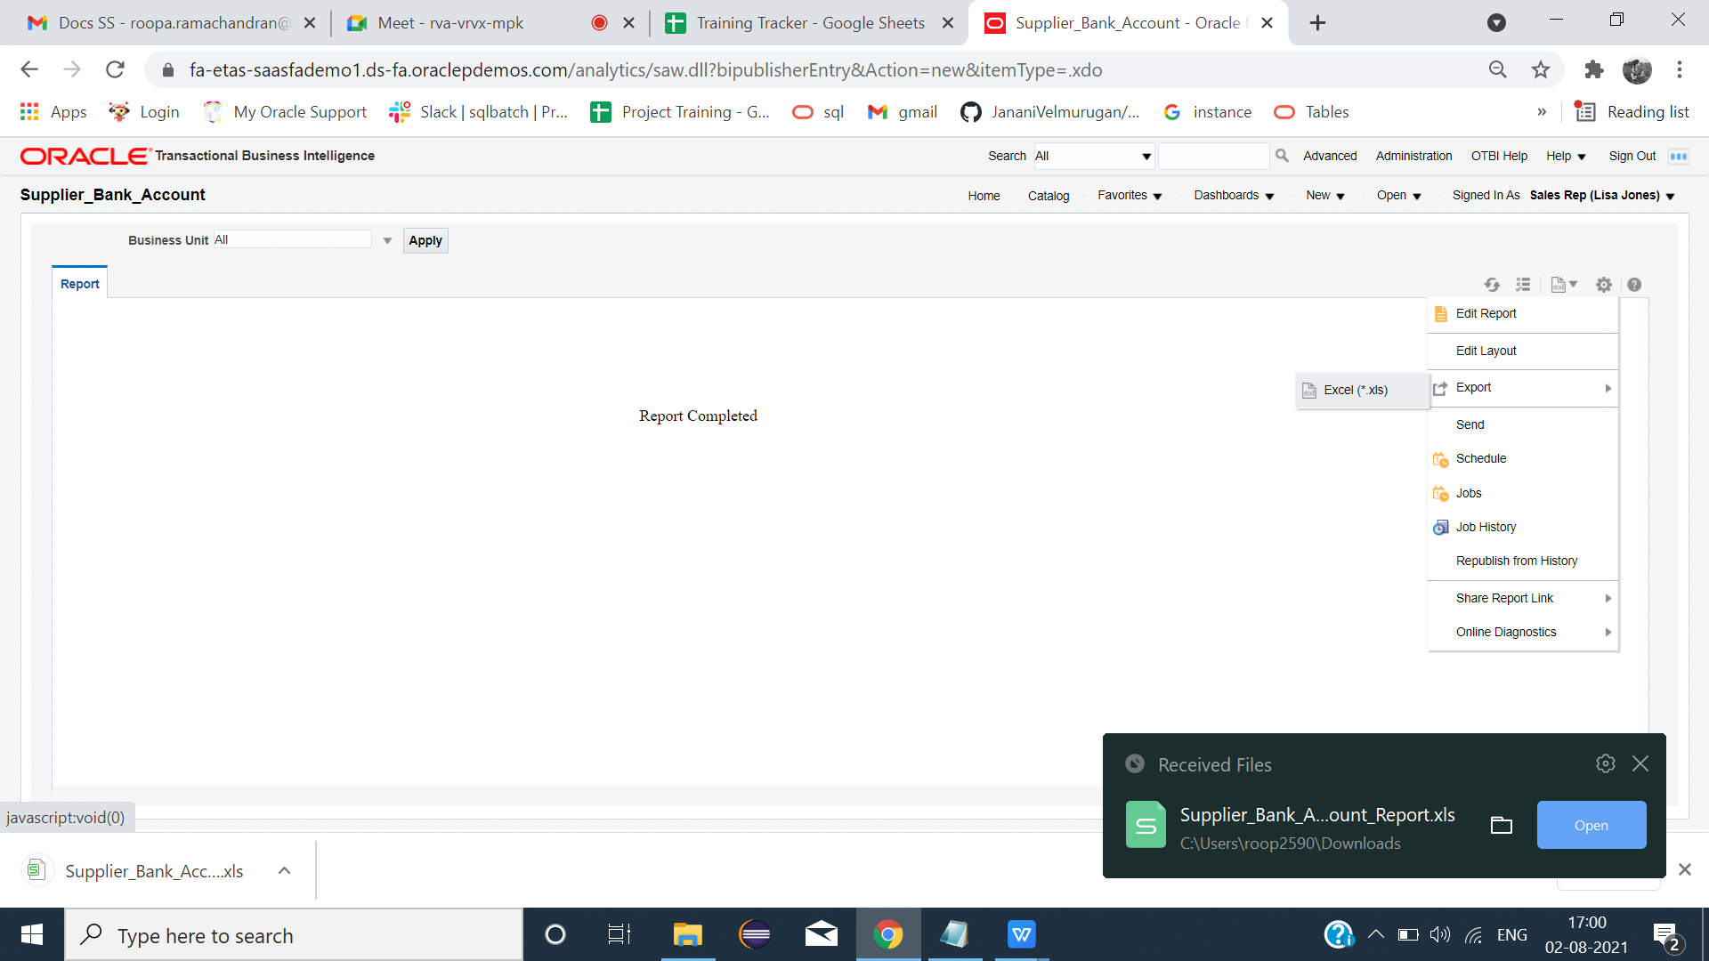

**Report:**

